**Management strategy evaluation of example Management procedures for atlantic bluefin tuna**

Tom Carruthers[1], Doug Butterworth[2]

*SUMMARY*

To do last

*KEYWORDS*

*Management Strategy Evaluation, bluefin tuna, operating model, management procedure*

# Introduction

A Management Strategy Evaluation (MSE, Butterworth 1999, Cochrane 1998) approach has been proposed for Atlantic bluefin tuna as a suitable framework for providing robust management advice consistent with the precautionary approach (GBYP 2017a). A principal task in the construction of an MSE framework is the development of operating models which represent credible hypotheses for population and fishery dynamics. Operating models are typically fishery stock assessment models which are fitted to data to ensure that model assumptions and estimated parameters are empirically credible (Punt et al. 2014, e.g. CCSBT 2011).

A general approach for testing MPs using MSE established two sets of operating models. The reference trials (‘Base case’) are considered to reflect the most plausible hypotheses and are the primary basis for identifying the best performing management procedure. Robustness trials are used to determine whether the management procedure behaves as intended in scenarios that are less likely.

In this paper the design of the reference set of operating models is described including the fit of these models to data.

# Methods

Seasonal, spatial, multi-stock, age structured operating models were fitted to a wide variety of fishery dependent and independent data (see Carruthers et al. 2015a and CMG 2017). Such data included electronic tags, Task II catch rate and genetics data informing stock of origin (for a summary of these data see Carruthers et al. 2015b and GBYP 2017b).

A reference set of operating models was identified that spanned three main axes of uncertainty for Atlantic bluefin tuna: (1) future recruitment, (2) current spatial distribution of abundance, (3) age-at-maturity (spawning fraction) / natural mortality rate (see Table 1 for the reference operating model design). Although this leads to 36 reference operating models in total, future recruitment scenarios are not applicable to model fitting. Consequently 12 unique model fits are presented here that cover factors 2 and 3 relating to abundance, maturity and natural mortality rate.

# Results

# Discussion

# Acknowledgements

This work was carried out under the provision of the ICCAT Atlantic Wide Research Programme for Bluefin Tuna (GBYP), funded by the European Union, several ICCAT CPCs, the ICCAT Secretariat and by other entities (see: http://www.iccat.int/GBYP/en/Budget.htm). The contents of this paper do not necessarily reflect the point of view of ICCAT or other funders and in no ways anticipate ICCAT future policy in this area.

# References

ABT-MSE. 2017. Atlantic bluefin tuna management strategy evaluation: an R package. Available at: [accessed September 2017]

Butterworth, D.S., Punt, A.E., 1999. Experiences in the evaluation and implementation of management procedures. ICES J. Mar. Sci. 56, 985-998.

Carruthers, T.R., Kimoto, A., Powers, J., Kell, L., Butterworth, D., Lauretta, M. and Kitakado, T. 2015a. Structure and estimation framework for Atlantic bluefin tuna operating models. ICCAT SCRS/2015/179.

Carruthers, T.R., Powers, J., Lauretta, M., Di Natale, A., Kell, L. 2015b. A summary of data to inform operating models in management strategy evaluation of Atlantic bluefin tuna. ICCAT SCRS/2015/180.

CMG. 2017. Specifications for MSE trials for bluefin tuna in the North Atlantic. GBYP Core Modelling Group. ICCAT Atlantic Wide Research Programme for Bluefin Tuna. Available at: [accessed September 2017]

GBYP. 2017a. ICCAT Atlantic wide research programme for Bluefin Tuna. Available online at: http://www.iccat.int/GBYP/en/index.htm [accessed September 2017]

GBYP. 2017b. Data to inform operating models for North Atlantic bluefin tuna. ICCAT Atlantic Wide Research Programme for Bluefin Tuna. Available at: [accessed September 2017]

Cochrane, K L., Butterworth, D.S., De Oliveira, J.A.A., Roel, B.A., 1998. Management procedures in a fishery based on highly variable stocks and with conflicting objectives: experiences in the South African pelagic fishery. Rev. Fish. Biol. Fisher. 8, 177-214.

Punt, A.E., Butterworth, D.S., de Moor, C.L., De Oliveira, J.A.A., Haddon, M., 2016. Management strategy evaluation: best practices. Fish Fish. 17, 303–334, http://dx.doi.org/10.1111/faf.12104.

## Table 1. The design of reference operating models. Note, only future recruitment level 1 are presented in this paper since future recruitment scenario is unrelated to fitting of operating models.

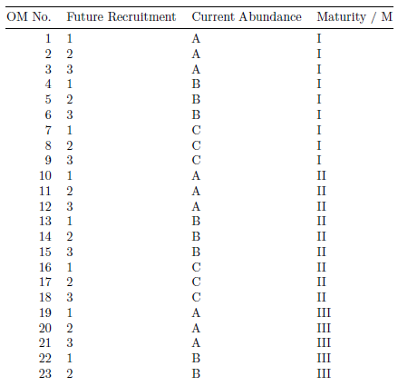

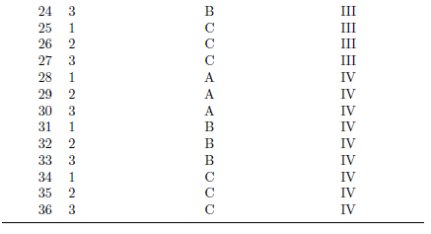

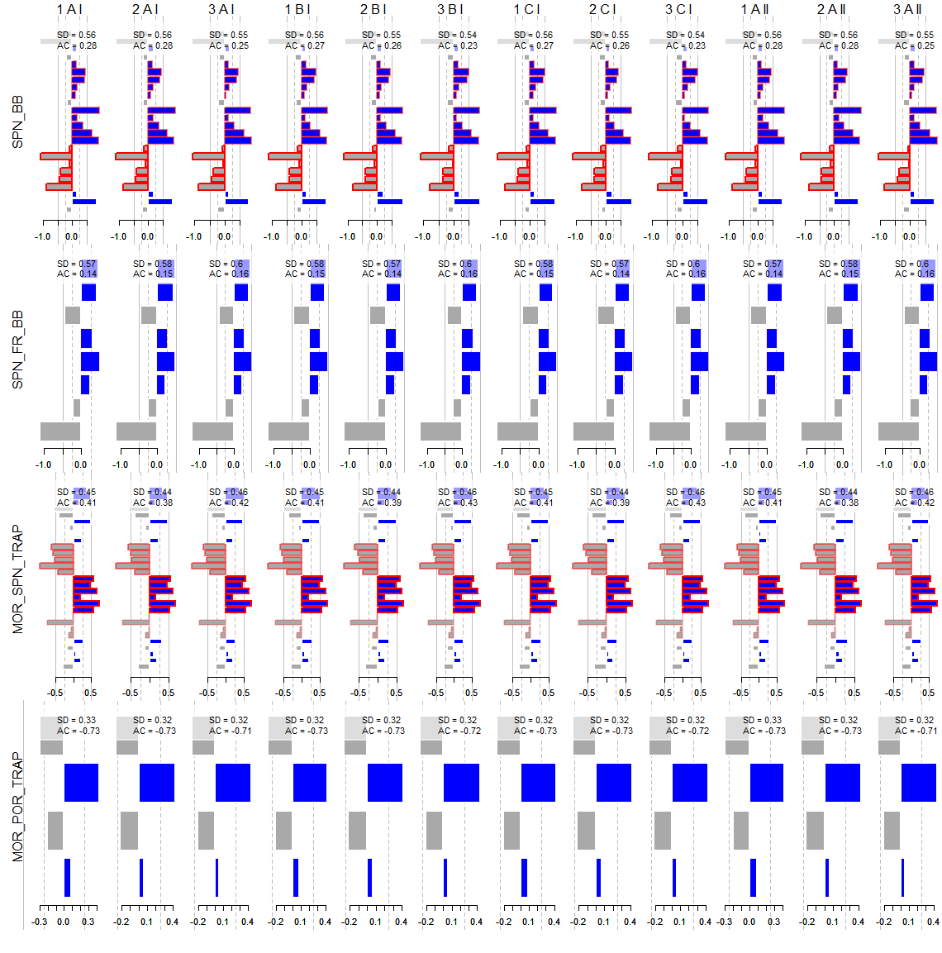

**Figure 1a**. Residuals for operation model fits (columns) to various assessment indices (rows)

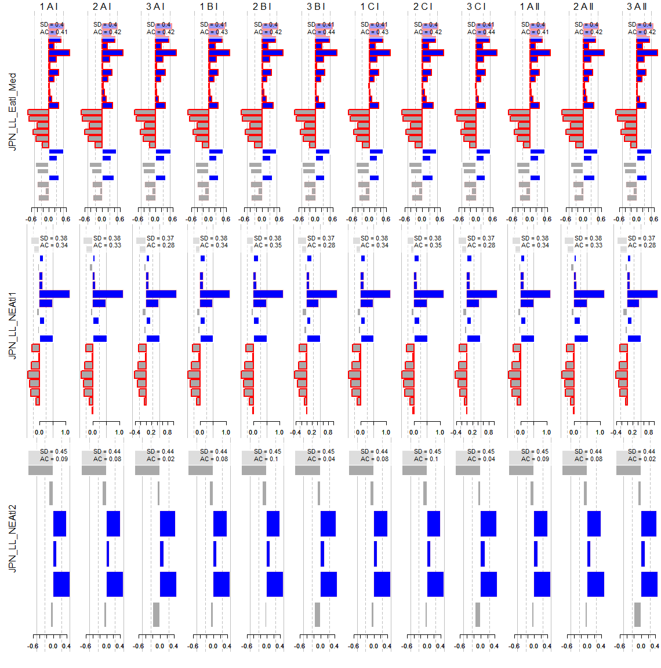

**Figure 1b**. Residuals for operation model fits (columns) to various assessment indices (rows)

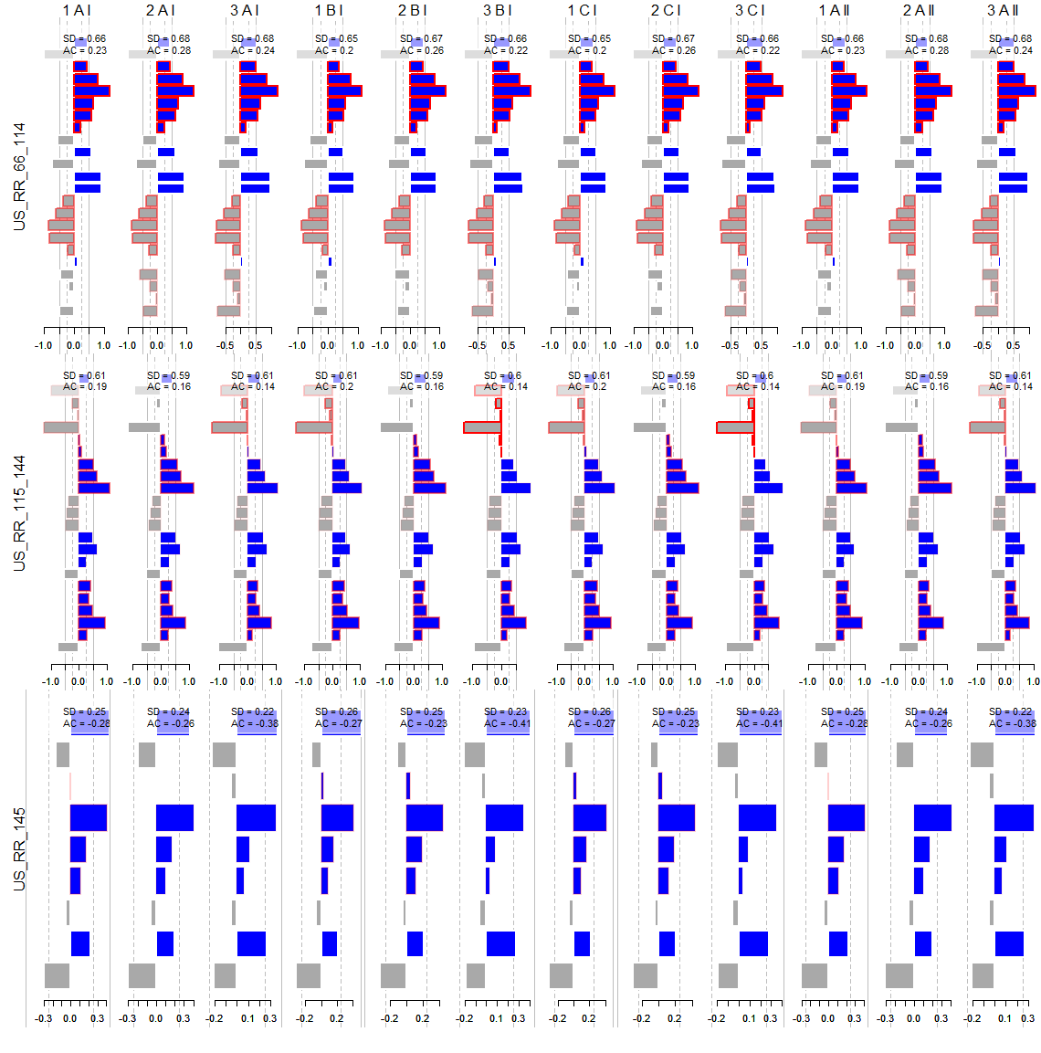 **Figure 1c**. Residuals for operation model fits (columns) to various assessment indices (rows)

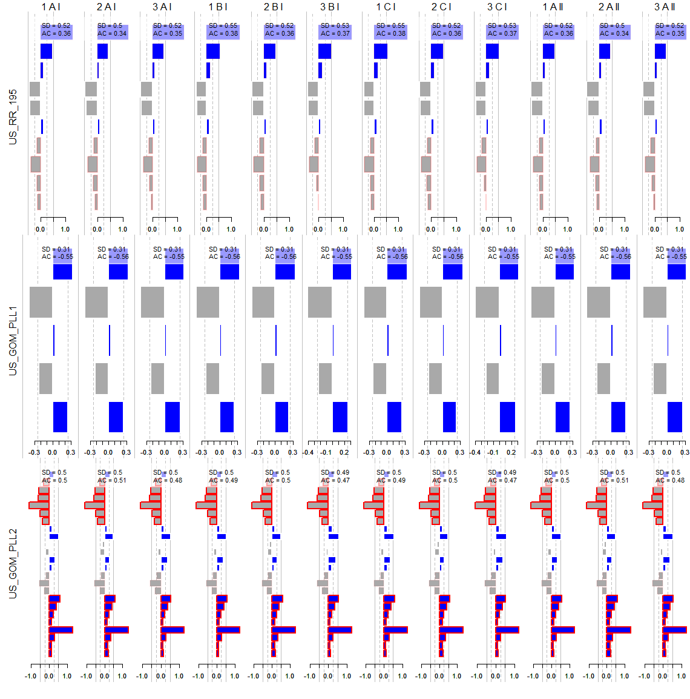

**Figure 1d**. Residuals for operation model fits (columns) to various assessment indices (rows)

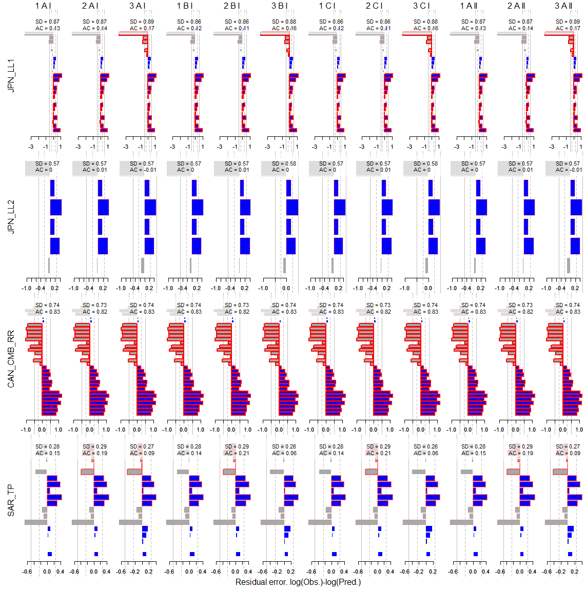

**Figure 1e**. Residuals for operation model fits (columns) to various assessment indices (rows)

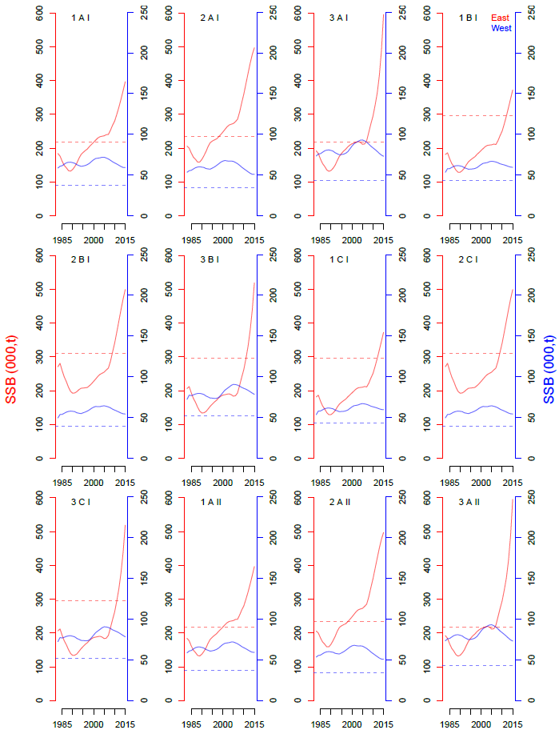

**Figure 2.** Predicted spawning biomass (East and West stocks) for each operating model (maximum posterior density estimates)

1. IOF, 2202 Main Mall, University of British Columbia, Vancouver, B.C., Canada, V6T 1Z4. [t.carruthers@oceans.ubc.ca](mailto:t.carruthers@oceans.ubc.ca)
2. Dpt. Maths and Applied Maths, University of Cape Town, Rondebosch 7701, South Africa. doug.butterworth@uct.ac.za